Here’s a **beginner-friendly explanation** of what lies **underneath TCP and UDP packets**, how they work, and why it's important in ethical hacking or cyber defense.

**🌐 What Are TCP & UDP Packets?**

Both **TCP** (Transmission Control Protocol) and **UDP** (User Datagram Protocol) are **transport layer protocols** in the OSI model. They **carry data** between systems in a network.

**🔍 Underneath the Packet: What's Inside?**

Let’s break it down by **layers** using the OSI/Internet model:

Application

Transport <-- TCP or UDP

Network <-- IP (Internet Protocol)

Link <-- MAC/Ethernet

When a packet is sent:

1. Your message (data) is **wrapped** in a **TCP or UDP** header.
2. Then it's placed inside an **IP** packet.
3. Then inside an **Ethernet (MAC)** frame.
4. Sent physically over the network.

**🧱 TCP Packet Structure**

| **Field** | **Purpose** |
| --- | --- |
| **Source Port** | Who sent it (e.g., 54321) |
| **Destination Port** | Who it’s for (e.g., 80 for HTTP) |
| **Sequence Number** | Tracks order of data |
| **ACK Number** | Acknowledges received data |
| **Flags** | SYN, ACK, FIN, etc. |
| **Window Size** | Flow control |
| **Checksum** | Error check |
| **Data** | Actual payload |

✅ TCP is **connection-oriented**, reliable, and uses **handshakes**.

**🧱 UDP Packet Structure**

| **Field** | **Purpose** |
| --- | --- |
| **Source Port** | Sender |
| **Destination Port** | Receiver |
| **Length** | Total length of packet |
| **Checksum** | Error detection |
| **Data** | Actual payload |

❌ UDP is **connectionless**, fast, but **not reliable** (no delivery guarantee).

**⚔️ Why This Matters in Hacking**

| **TCP** | **UDP** |
| --- | --- |
| Port Scanning with nmap | DNS Amplification Attacks |
| SYN Floods (DoS) | VoIP/Streaming attacks |
| Session Hijacking | DNS Spoofing |
| Wireshark/Packet Analysis | Malware C&C over UDP |

**🧠 Simple Analogy**

* **TCP** is like sending a letter **with return receipt** and tracking number.
* **UDP** is like dropping **a postcard** in the mailbox — faster, but no guarantee it’ll arrive.

**K&H MFG. CO. – When the abstract concept of TCP/IP becomes concrete…**

The Internet has penetrated into every aspect of our daily life and provides a fundamental connection with many of the most state-of-the-art technologies. TCP/IP (the abbreviation of Transmission Control Protocol/ Internet Protocol) is the core technology of the Internet, and it is a set of rules governing communication between devices on the network. In order to promote better Internet applications, it is essential for Internet users at all levels to understand TCP/IP. Traditionally, the TCP/IP concept is very abstract because it can only be accessed through textbooks. To improve the efficiency and effectiveness of learning TCP/IP, the Internet TCP/IP Protocol Training System (ITS-101A) is designed to embody the TCP/IP concept through hardware-based experiments.

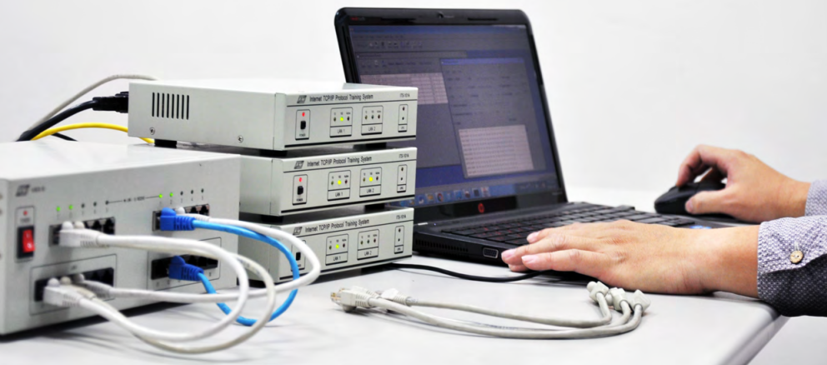To describe how TCP/IP is used to communicate systems over the Internet, the most commonly introduced framework is the Open Systems Interconnection Model (OSI Model). It defines a foundation of network services architectures and enables various communication systems to be interconnected and interoperable on the network. The OSI model has 7 abstraction layers, and the Internet TCP/IP Protocol Training System (ITS-101A) provides 25 experiments covering Layer 2 to Layer 7, discussing what TCP/IP is and how it works behind the Internet.

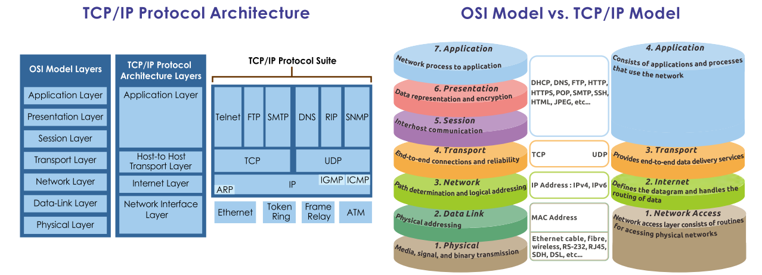

The Internet TCP/IP Protocol Training System (ITS-101A) is a hardware-based training system which covers the theoretical and practical foundations of learning TCP/IP. In order to help students understand the operation principles of TCP/IP, the system discloses the internal work of the protocol software and simulates network transmission, so that students can monitor the transmission status and analyze different network behaviours through clear observation. Apart from explaining the definitions of TCP/IP, its experiments, such as how to set up a firewall/email and how to establish TCP/IP connections, are also introduced. One of its most remarkable functions is that it provides several experimental methods for modifying the behaviour of TCP/IP to help students understand the relationships between IP, ICMP, TCP, and UDP.

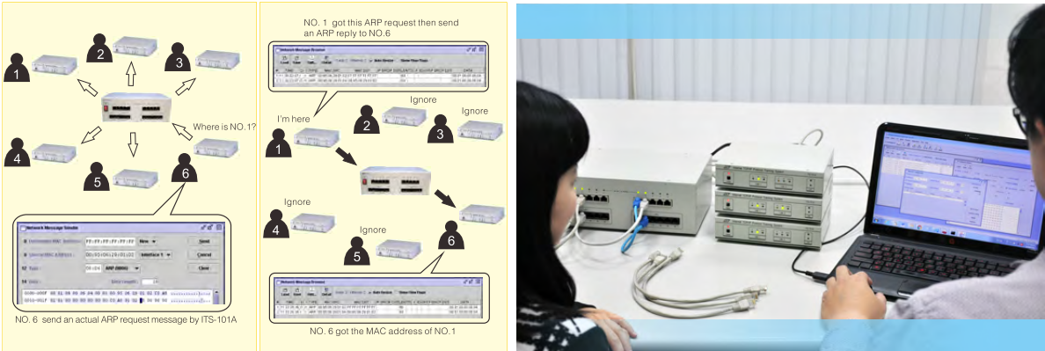

System features:  
1. Real-time packet monitor  
Students can observe data sent in packets (e.g.: TCP, UDP, IP, ICMP & Ethernet frame) and understand how packets operate while monitoring the transmission process.  
2. Packet generator  
Through the easy-to-operate software interface, students can generate packets and send them consecutively. They can also modify the value for every single parameter in the header to experiment different hypothesis.  
3. Congestion generator  
Students can create various network congestion scenarios, including packet delay, packet loss, and packet error for fault simulation.  
4. Programmable router  
The modules can be emulated as a programmable router, where students are able to write programs, modify protocols (e.g.: including a firewall/NAT protocol so that this module becomes a router with a firewall/NAT function).

Article Submitted by:  
Jamie Hung [jamie@kandh.com.tw](mailto:jamie@kandh.com.tw)  
K&H MFG. CO., LTD  
Taiwan, Province of China

**TCP/IP Reference**

This book assumes basic familiarity with TCP/IP and networking concepts. You won't find a primer on the OSI seven-layer model or a rundown of the Berkeley Socket API within these pages. For a comprehensive guide to TCP/IP, I recommend “[*The TCP/IP Guide*](http://www.amazon.com/dp/159327047X?tag=secbks-20)” by Charles Kozierok or the old classic “[*TCP/IP Illustrated, Volume I*](http://www.amazon.com/dp/0201633469?tag=secbks-20)” by W. Richard Stevens.

While TCP/IP familiarity is expected, even the best of us occasionally forget byte offsets for packet header fields and flags. This section provides quick reference diagrams and field descriptions for the IPv4, TCP, UDP, and ICMP protocols. These beautiful diagrams are used by permission of author Matt Baxter.

**Figure 1. IPv4 header**

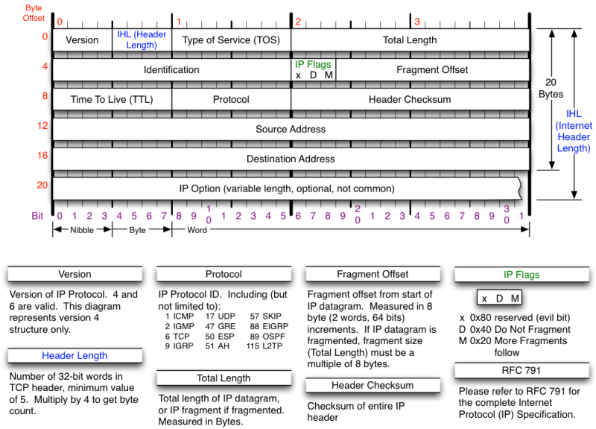

**Figure 2. TCP header**

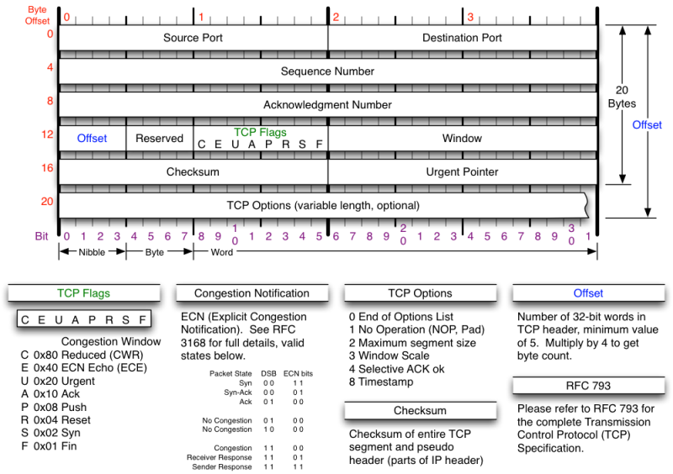

**Figure 3. UDP header**

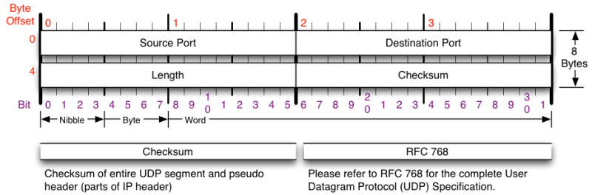

**Figure 4. ICMP header**

